***Run N Gun Final Report***

***40291478 – Ciaran McMahon***

https://github.com/CIARANEK/Games_Engineering_CW_RunNGun

Github repo - [GitHub - CIARANEK/Games_Engineering_CW_RunNGun](https://github.com/CIARANEK/Games_Engineering_CW_RunNGun)

**Introduction**

My assignment, since the group had gone, and I was just by myself, was to create a game idea and then go and create it, it had to be inspired by other games and have a good handful of features for the user.

At the time we had all decided to make “Run N Gun”. It is based upon other 2D shooter games and their elements that were covered in the games engineering module. I had decided to continue by myself and work on Run N Gun and make it real.

Our inspiration for “Run N Gun” came from many of the modules game examples that we had been working through like Pong, Space invaders and Pac-man. As well as the module material we had taken a lot of inspiration from all other top down shooter games available. Left 4 Dead was also a massive part of the reason behind “Run N Gun” but in a single player sense instead of relying on a team of people to help you.

The single player survival horror genre is one of my favorites as it really immerses you in the game and, if it has it, its story. One of my all time favorite games is Dead Space 1 (and 2). This is where I really took inspiration for Run N Gun but very loosely as Run N Gun is a 2D shooter with zombies.

Run N Gun now is consisting of a player and spawning zombies. The player fires bullets at enemies that spawn in random points of the window. The user has a HP of 10 and the zombies also have HP, so you know how many bullets they will take. The game is endless until the player has been hit 10 times then its game over. The player kills the zombies to increase their score.

**Changes / omissions**

The original concept of Run N Gun has changed since the Game Design Document due to time constraints, lack of team mates and other priorities and ability.

Instead of the player running out of time to end the game or the player gets hit by a zombie, the user can now battle zombies that spawn in until they get Hit 10 times. The player has a HP of 10 and now zombies also have HP so that the zombies have varied levels of difficulty.

I was not able to implement the high score feature as well as the power ups that the user would get to give them certain abilities/weapons. Two players were thought about in the process but never went any further.

**Software design**

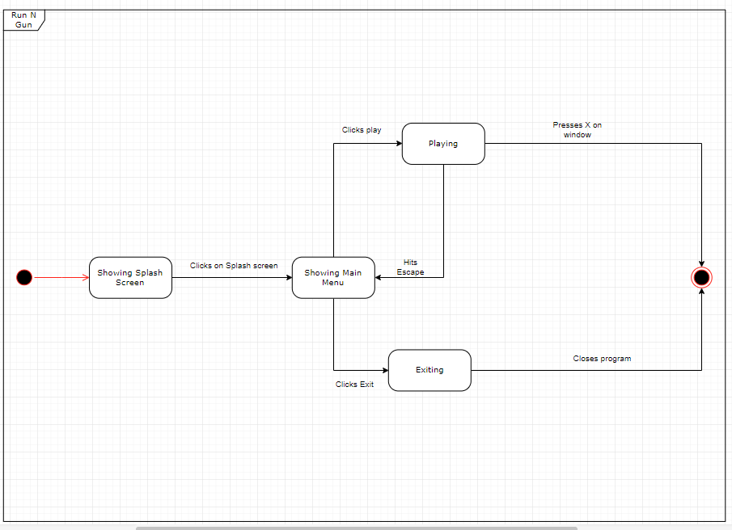

This diagram shows the different game states that Run N Gun goes through with the users interactions.

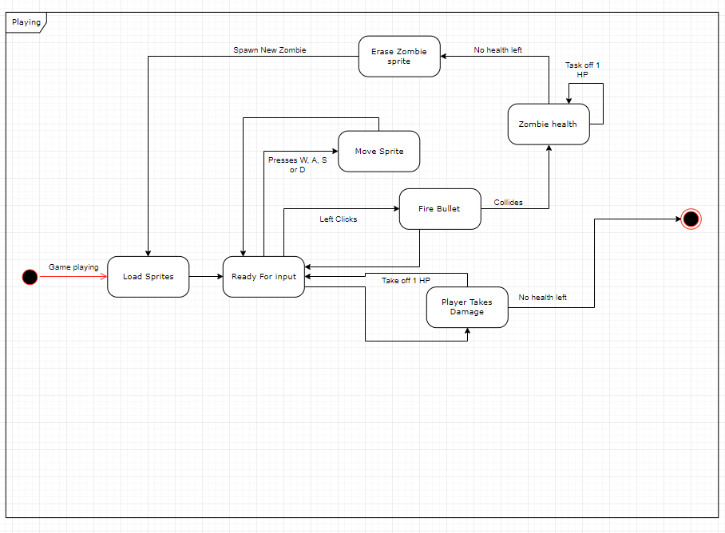

The above state diagram shows the interactions the user can take when the game is playing/ in the playing game state.

**Implementation**

First screen that appears once the game has been started. This is the splash screen displaying just the title of the game, Run N Gun. This screen will stay displaying until the user clicks.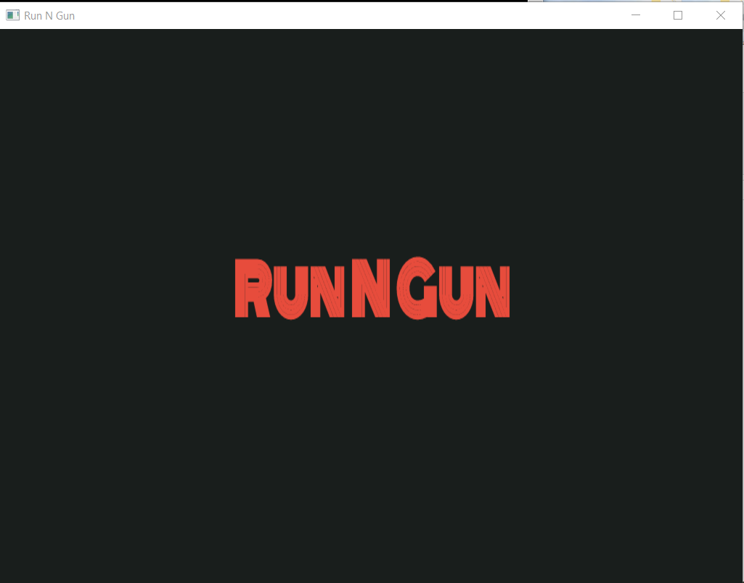

Once the user has clicked on the splash screen they are taken to the main menu. Here the user can exit the program or start the game by clicking on the appropriate areas of the screen.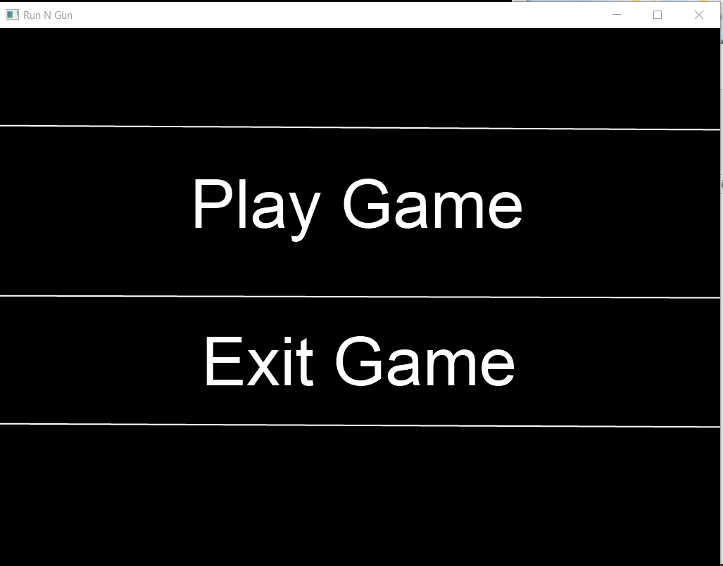

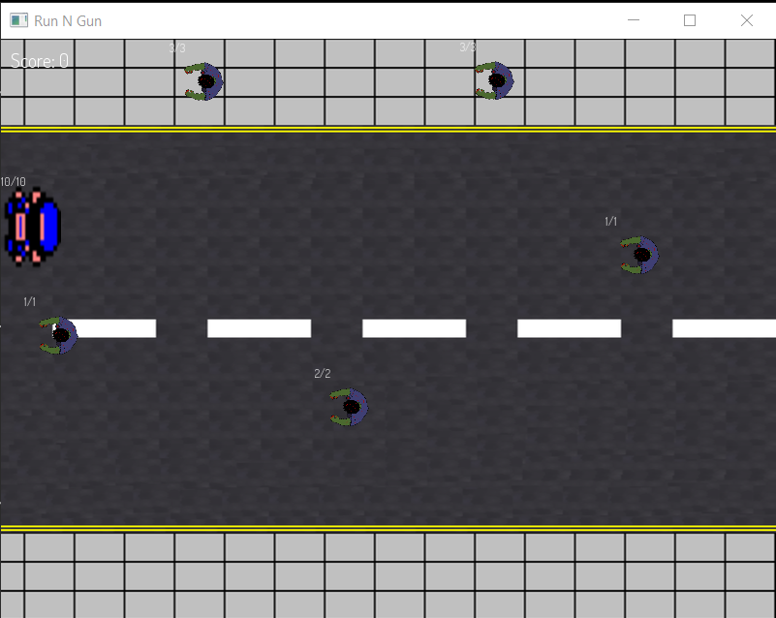

This is the main game that the user can interact with. The player moves by using WASD on the keyboard and left click on the mouse to fire bullets. The player has a set amount of health and the game will end once the health has been depleted. The user gathers a score by killing the zombie sprites.

**Evaluation of implementation**

Compared to the original concept of Run N Gun the finished prototype is very similar. The only changes are that some features were not implemented, and two player modes were never developed. Overall the games core gameplay is still the very much the same as discussed in the original pitch.

There are many other games in this genre of video game. Compared to them it offers very similar functions. Making this game I knew there were many like it, so I wanted to use original sprites and backgrounds so that I would stand out a bit more and be unique in that sense. If I compare it to the games that inspired Run N Gun then it’s completely different as the inspirations are mostly AAA title games and have a lot of features, including multiplayer modes.

If feel like the quality of the game is good, not great, and does what its intended to. It runs very smoothly and feels right moving with the keyboard and shooting with the mouse. To improve this game and really finish it I would like to add all the originally proposed features discussed before, high score menu, two player modes and the power up system. I also really would like to add different zombie sprites to represent the tougher zombies that spawn in. Different levels as well as and end game fight with a boss of some kind. Adding an end game to Run N Gun would be very beneficial as it would give the player a sense of accomplishment. The final improvement I can think of is spawning the player in the center of the screen and spawning zombies all around the player and have the zombies track and attack the player as they move.

**Resources**

Repo link added at the top of the page but also in the Run N Gun folder/installer.

Sprites/Background/ Splash screen and menu all made by me using mainly pixel editor and just online poster makers.

Background audio came from newgrounds – zombie robot audio track

Player death/ gun shot came from freesound.org – game_over_voice_effect_01, Gun shot & Player hit

Zombie spawn/ death audio came from freesound.org – Zombie 1 & Deep Zombie 3